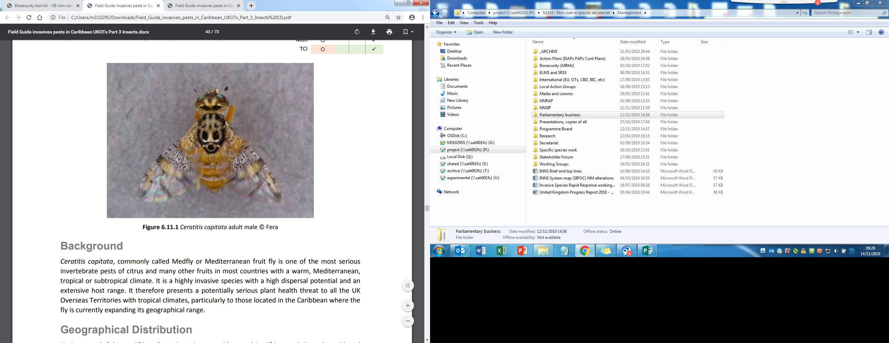

**What is it?**A fruit fly from sub-Saharan Africa. Mediterranean fruit fly is a serious pest of citrus and other fruits.

**Suspected sightings should be reported immediately using the details   
provided at the bottom of this poster.**

**Where might I see it?**Fruit flies can be found as eggs or larvae in fruits or as adults caught in traps.   
Affected fruit may have puncture marks or globules of sugar on the skin.

**Have you seen this pest?**

**MEDITERRANEAN FRUIT FLY**

*Ceratitis capitata*

**1664 491 2075**

Please report any sightings of this species by calling:

[insert website address?]

Wings 3.6—5 mm (0.1”) long

Image: Fera

Black with a narrow wavy yellow band across the base

Yellow crossbands on wings