Invasive species activity
This session takes approximately one hour and is suitable for 7-11 year olds

Learning outcomes
Students will learn what ‘invasive species’ are, where they have come from, what makes them so successful, and the harmful impacts they can have on native wildlife. Using what they have learned, the students will identify some common native and invasive species, and come up with some simple ways to help to prevent the spread of invasive species.
What do you need?

• Computer and projector (or printed copies of the presentation slides).
• Invasive Species Activity PowerPoint presentation.
• Printed copies of the materials on pages 3-10 of this pack.
Preparation guidelines:
1. Read through the instructions to make sure you understand the activity.
2. Download the Invasive Species Activity PowerPoint presentation.
3. Print off the materials on pages 3-10 of this pack (either one per student or one per group, depending on whether you would prefer them to work independently or in groups).
4. Cut out the cards for activity one, and clues for activity two.
How to run the session:
1. Find out what the students already know about invasive species - this makes a good starting point for further discussion.
2. Introduce the concept of invasive species by working through the first part of the PowerPoint classroom presentation.
3. Explain that the students will be asked to carry out two activities:
• To decide whether some examples are native or invasive species.
• To look at some scenarios where invasive species have been found in Montserrat, work out how they got there, and decide how we could prevent this from happening again.
See page 2 for detailed instructions for each activity.
Suggestions for extension activities:
Ask the students to design posters to show others how they can help to prevent invasive species from being spread.
1
1

Invasive species activity
This session takes approximately one hour and is suitable for 7-11 year olds

Instructions for activities one and two.
Activity one: Native or Invasive?
1. Split the class into small groups of 3 - 5 (or individuals if you want them to work independently).
2. Give each group (or individual) a copy of the image of Montserrat and the cards.
3. Explain that they are going to try and work out whether they think each animal is a native species, or an invasive species, and what it is.
4. They should group the cards into two piles (native and invasive).
5. If any groups finish ahead of time ask whether they think any of the invasive species might harm the native species, and how.
6. Bring the class together as a group and go through each species one by one (see slides
6-31 of the presentation), asking the class what they think each time before revealing the answers.
Activity two: Detective challenge
1. Split the class back into their previous groups.
2. Give each group (or individual) a copy of the four case files and the clue cards (they should only use these if they are struggling).
3. Explain that they are going to be invasive species detectives and try to solve some ongoing cases where an invasive species is causing a problem in Montserrat.
4. They should read the problem on each case and then try to come up with an answer to each of the two questions:
• How did the invasive species get to Montserrat?
• How could we stop it from happening again?
5. They should write their answers in the boxes on each case.
6. If any groups finish ahead of time, ask whether they can think of any other ways that
invasive species could get to Montserrat.
7. Bring the class together as a group and go through each case one by one (see slides 33-46 of the presentation), asking the class what they think each time before revealing the
answers.
Activity 1: Native or invasive
Cut out the cards

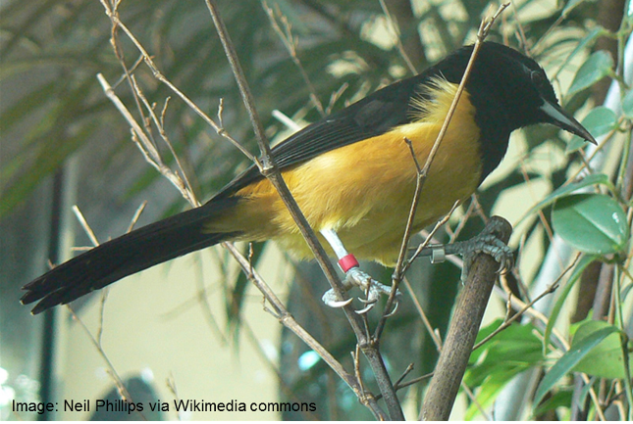
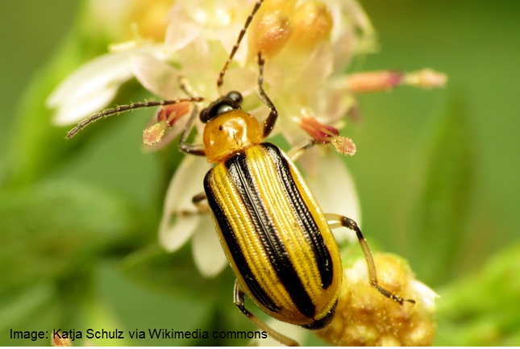
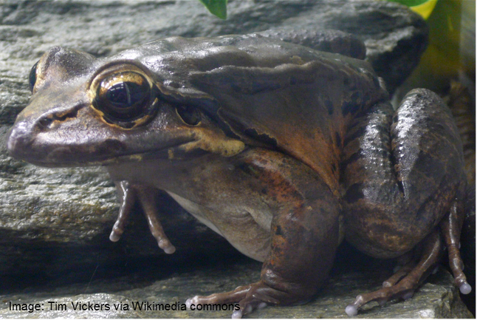
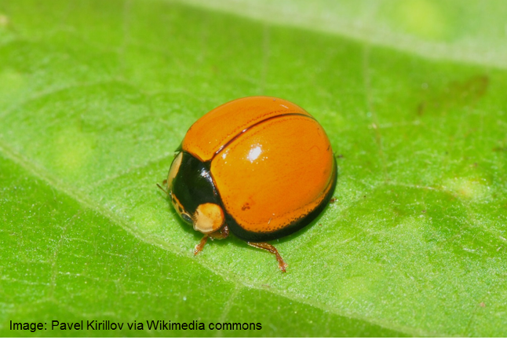
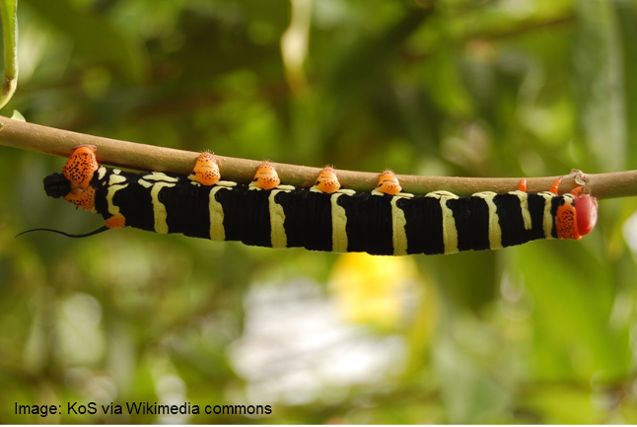
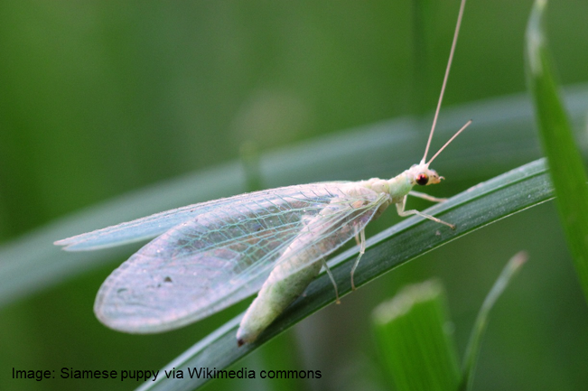
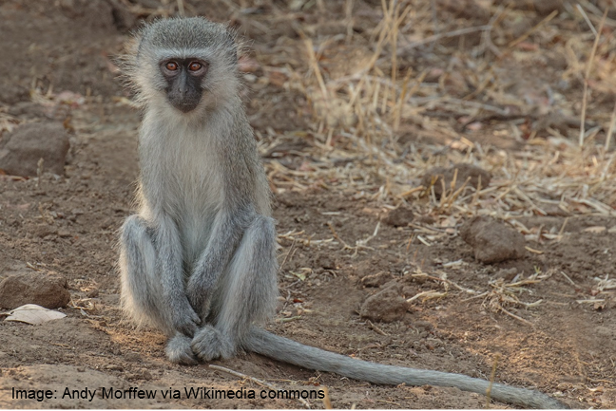
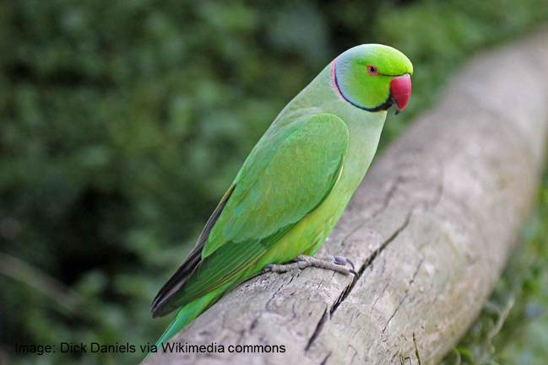
Activity 1: Native or invasive
Place the cards on and around the island of Montserrat.

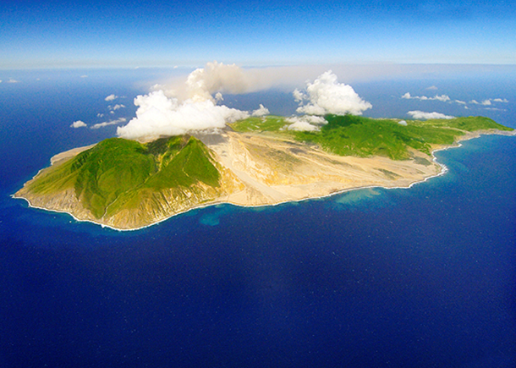
Montserrat
Image: Igor Kravtchenk
Write your answer here
How could we stop this from happening again?

Write your answer here
An invasive Cuban tree frog has been found in the wardrobe of someone’s house. This frog will eat other frogs and lizards and its skin
makes a sticky substance that can make your eyes itch and sting.

Detective’s report:
How do you think the frog got from Cuba to a wardrobe in Montserrat?

How could we stop this from happening again?

Activity 2: Detective challenge
Case 1: the tree frog in the wardrobe.
An invasive boa constrictor snake from South America has been rescued from a park. This snake can grow to be very large and eats lots of other animals.

Detective’s report:
How do you think the snake ended up in a park in Montserrat?

How could we stop this from happening again?

Write your answer here
How could we stop this from happening again?

Write your answer here
Activity 2: Detective challenge
Case 2: The snake in the park.
Write your answer here
How could we stop this from happening again?

Write your answer here
A farmer has found a giant African land snail in one of their fields. This large snail eats lots of important plants that we grow for food.

Detective’s report:
How do you think the snail ended up in a field in Montserrat?

How could we stop this from happening again?

Activity 2: Detective challenge
Case 3: The snail in the fields.
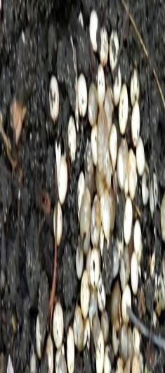
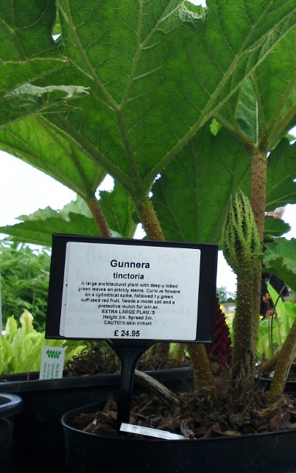
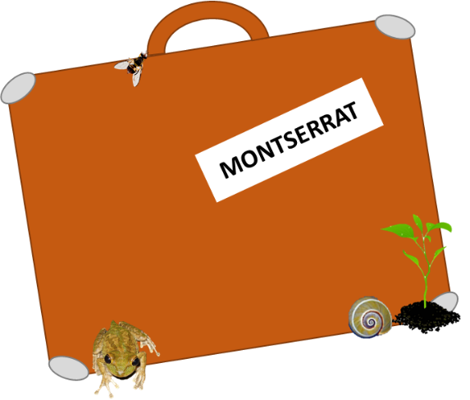
Someone has found a tomato leaf miner
caterpillar from South America in their
lunch. This caterpillar eats tomatoes, fruit, and other plants that we grow for food.

Detective’s report:
How do you think the caterpillar ended up in someone’s lunch in Montserrat?

How could we stop this from happening again?

Write your answer here
How could we stop this from happening again?

Write your answer here
Activity 2: Detective challenge
Case 4: The caterpillar in the lunch.
..Snail eggs are tiny and can be carried in mud

Image: Roberto E. Vogler & Ariel A. Beltramino-2013
.Some of the
food that we
eat in
Montserrat is
imported from
abroad
The lunch
contained
a tomato
sandwich
.A suitcase
is laying
on the
floor in
the
wardrobe
Activity 2: Detective challenge
Cut out the clues.
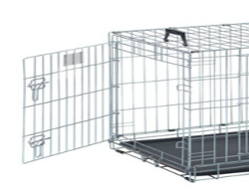
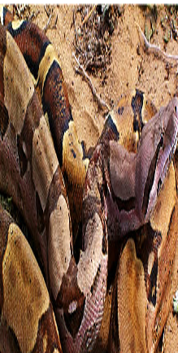
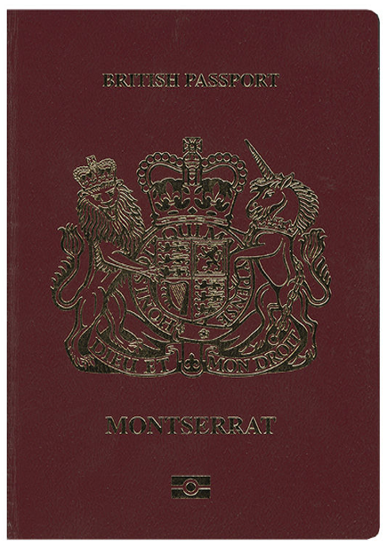
.An empty cage
used to carry
pets has been
found in the
park
.Last month there were lots of muddy footprints and tyre tracks on the ferry
.The snake is very large
Image: Tod Baker
.There are
some recent
plane tickets
and a
passport on
a chair in
the bedroom

1
Activity 2: Detective challenge
Cut out the clues.

