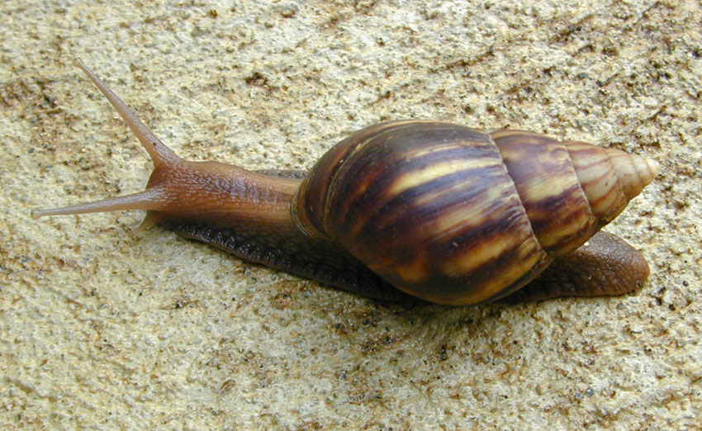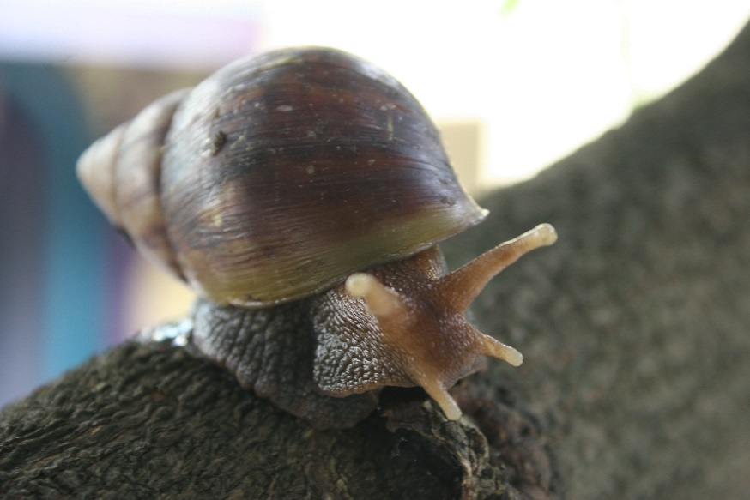

[insert website address?]

**What is it?**A large invasive snail from East Africa. Giant African land snail is a major plant pest which feeds on a range of important plants including vegetable and food crops.

**Suspected sightings should be reported immediately using the details   
provided at the bottom of this poster.**

**Where might I see it?**Adult snails hide during the day, coming out at dusk to feed. May be found in   
agricultural areas, coastland, natural forest, riparian zones, shrublands, urban   
areas and wetlands.

**Have you seen this pest?**

**GIANT AFRICAN LAND SNAIL**

*Lissachatina fulica*

**1664 491 2075**

Please report any sightings of this species by calling:

Shell cone-shaped and usually 5—10 cm (2-4”) long but can be up to 20 cm (8”)

Shell usually light brown   
with brown and cream bands

Tip of shell lighter

Image: Eric Guinther under Creative Commons Attribution Share Alike 3.0 unported license

Two pairs of tentacles on the head