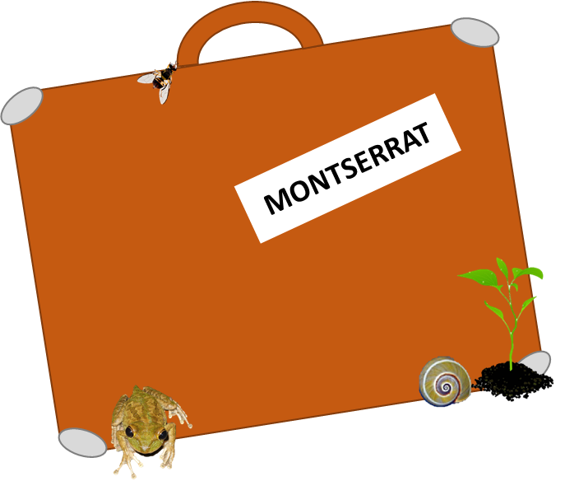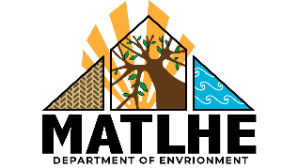

**Travelling to Montserrat?**

**Diseases and invasive   
species threaten our   
wildlife and crops.**

**.  
Don’t bring them here.**

**Check your luggage and clothing for hitchhikers before travelling.**

**.**

**You need a permit for plant   
material or seeds.**

**Found something?   
Call: 1664 491 2075**

**Don’t bring:**

Mango

Banana

Citrus

Avocado