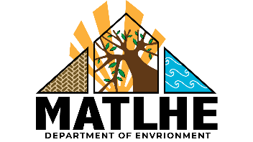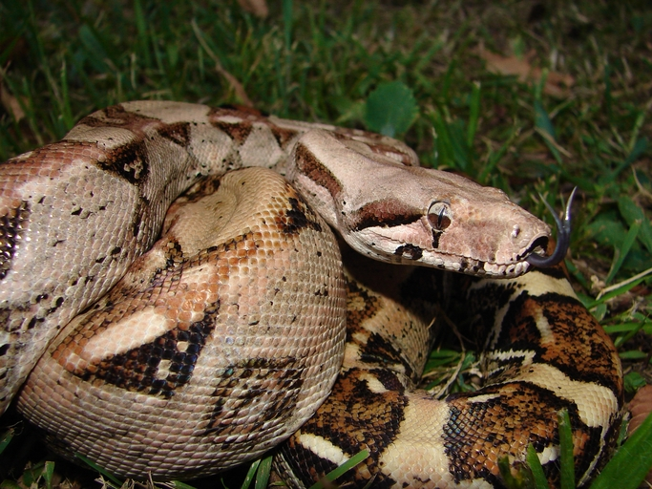

**What is it?**A large snake from Central and South America. Boa constrictor feeds on a variety of animals, posing a risk to small children, pets, small farm animals, and wildlife.

**Suspected sightings should be reported immediately using the details   
provided at the bottom of this poster.**

**Where might I see it?**May be seen anywhere around buildings or in the forest - on the ground or in lower tree branches.

**Have you seen this pest?**

**BOA CONSTRICTOR**

*Boa constrictor imperator*

**1664 491 2075**

Please report any sightings of this species by calling:

[insert website address?]

Adults may grow to more than 9 metres long

Naturally have a pattern of 30 brown or reddish patches on a lighter background but this can vary in snakes bred for the pet industry

Image: Eric Guinther under Creative Commons Attribution Share Alike 3.0 unported license